TE 404/405 Integrated Project

Rebels and Revolution: The Fight for Freedom

TE 404/405

Dr. Justin Detmers & Carol Opie

April 1st, 2025

**Unit Title:** Rebels and Revolution: The Fight for Freedom

**Unit Family Letter**:

Dear Families,

I hope the start of 2025 is treating you well. I am writing to inform you that starting February 17th, I will be teaching a unit of social studies to the fifth grade. Our unit is focused on the American Revolution.

Some topics that will be covered include: tensions leading up to the revolution, whether to declare independence or not, the declaration of independence, and the American Revolution.

The big ideas we will be exploring in this unit are fairness, representation, and justice. Some key concepts that we will dive deeper into are the different acts the British imposed on the colonists and the effects, different battles/turning points in the war, dissecting the Boston Massacre, important colonists and loyalists, the process of creating the Declaration of Independence, and the outcome of the war.

By the end of this unit, students will be able to understand what led up to the revolution and how we won the war. Throughout this unit, we will include activities that allow students to debate, role-play, be creative, and practice some key writing skills.

I am thrilled to have this opportunity to engage your students in meaningful social studies content and make history relevant to their lives.

Warmly,

Meghan Hingst

**Building Pedagogical Content Knowledge**

| Source | APA |
| --- | --- |
| The Events that led to the Revolutionary War for Kids (<https://www.youtube.com/watch?v=7BxSvgRKIy4>)   * Summary video on the events leading up to the start of the Revolutionary War. * Will use after the TCI lesson about tensions leading up to the war. | History for Humans. (2022, May 5). *The Events that led to the REVOLUTIONARY WAR for Kids* [Video]. YouTube. <https://www.youtube.com/watch?v=7BxSvgRKIy4> |
| Why did the Colonists Declare Independence? (<https://www.youtube.com/watch?v=pTliCI6uwmo>)   * Short video on the “why” behind declaring independence, not taught in TCI * Will use after the TCI lesson on declaring independence | Untold History. (2023, June 14). Why did the Colonies Declare Independence? [Video]. YouTube. <https://www.youtube.com/watch?v=pTliCI6uwmo> |
| The Boston Tea Party by Russell Freedman  Read aloud resource   * Picture book about The Boston Tea Party * Will use before beginning our lesson about the Tea Party | Freedman, R. (1999). *The Boston Tea Party*. Holiday House. |
| Samuel Adams: The father of American independence by S.A. Kramer   * Picture book about the importance of Samuel Adams’ role in the Revolution * Will use before our section on important figures, Samuel Adams is brushed over and I would like to talk about him more in depth than the curriculum provides | Kramer, S. A. (2001). *Samuel Adams: The father of American independence*. Holiday House. |
| Article: Women in the Revolutionary War   * Talks about women’s role in the revolutionary way * Will use when talking about different sides of the war, women are not mentioned in curriculum | Ducksters. (n.d.). *Women in the Revolutionary War*. Ducksters. Retrieved January 30, 2025, from <https://www.ducksters.com/history/american_revolution/women_revolutionary_war.php> |
| Article: African Americans in the Revolutionary War   * Talks about important Black figures in the War * Will use when talking about the different sides of the war, this is not mentioned in the TCI curriculum | Ducksters. (n.d.). *African Americans in the Revolutionary War*. Ducksters. Retrieved January 30, 2025, from <https://www.ducksters.com/history/american_revolution/african_americans_revolutionary_war.php> |
| Paul Revere’s engraving of the Boston Massacre   * Primary source of Boston Massacre from 1770 * Will use when talking about this event + talking about propaganda | Gilder Lehrman Institute of American History. (n.d.). *Paul Revere’s engraving of the Boston Massacre, 1770*. Gilder Lehrman Institute of American History. Retrieved January 30, 2025, from <https://www.gilderlehrman.org/history-resources/spotlight-primary-source/paul-reveres-engraving-boston-massacre-1770> |
| Common Sense by Thomas Paine   * Primary source from Revolution * Will use when dissecting reasons for the revolution | Paine, T. (1776). *Common sense*. Retrieved January 30, 2025, from <https://www.gutenberg.org/ebooks/14740> |

Social Studies, Literacy, and Anti-Bias Standards

Michigan K-12 Social Studies Standards

* 5 – U3.1.1 Describe how the French and Indian War affected British policy toward the colonies and subsequent colonial dissatisfaction with the new policy.
* 5 – U3.1.2 Describe the causes and effects of events such as the Stamp Act, the Boston Massacre, the Boston Tea Party, and the Intolerable Acts.
* 5 – U3.1.3 Using an event from the Revolutionary era, explain how British and colonial views on authority and the use of power without authority differed (views on representative government).
* 5 – U3.1.4 Describe the role of the First and Second Continental Congresses in unifying the colonies.

Common Core ELA Standards

* Write opinion pieces on topics or texts, supporting a point of view with reasons and information. a. Introduce a topic or text clearly, state an opinion, and create an organizational structure in which ideas are logically grouped to support the writer’s purpose. b. Provide logically ordered reasons that are supported by facts and details. c. Link opinion and reasons using words, phrases, and clauses (e.g., consequently, specifically). d. Provide a concluding statement or section related to the opinion presented.
* Conduct short research projects that use several sources to build knowledge through investigation of different aspects of a topic.
* Draw evidence from literary or informational texts to support analysis, reflection, and research.

Anti-Bias Standard

* JU.3-5.15: I know about the actions of people and groups who have worked throughout history to bring more justice and fairness to the world

Learning Targets

* Students will be able to recognize what led up to the American Revolution by reading and discussing the introduction passage in TCI.
* Students will be able to explain why the French and Indian War added to unrest among the colonies by reading and responding to Section 1 in TCI.
* Students will be able to identify the Proclamation line made by King George III and discuss by reading Section 2 in TCI and responding to the writing prompts given.
* Students will be able to argue the Quartering Act by reading the passage given and creating their own stance based on the information provided.
* Students will be able to relate the Intolerable Acts to modern-day politics by reading and analyzing the TCI text along with primary source documents.
* Students will be able to design their own tax flyers to the colonists by summarizing and selecting evidence from the TCI text.
* Students will be able to interpret Paul Revere’s Boston Massacre etching by analyzing primary source documents and the TCI text.
* Students will be able to debate for or against the Revolutionary War by researching primary and secondary source documents as well as rereading the TCI chapter sections.

Big Powerful Ideas

* The cause of the American Revolution was aided by civil unrest amongst the colonists because of the lack of representation when making large-scale decisions on the people.
* When groups of people band together for a common cause, changes can be made.
* Paul Revere’s Boston Massacre etching was a key turning point in the events leading up to the Revolution because of how he portrayed the colonists and the British soldiers.

Key Concepts/Vocabulary

* **Boycott:** a collective action where people refuse to buy, use, or support a person, organization, or country.
* **Representation:** the action of speaking or acting on behalf of someone or the state of being so represented.
* **Democracy:** a system of government by the whole population or all the eligible members of a state, typically through elected representatives.
* **Revolution:** a [forcible](https://www.google.com/search?client=safari&sca_esv=e43f164304cbaefd&rls=en&q=forcible&si=APYL9bto9KfN6HH0KMpfhyCmyq0bpZyxq2nsJfLHDKefTEvm-rqeHDuIr6sngf_INAJROaGf7jPAYQ-ufpBtEcAkJUiQ9My3CbCEgTyoH-JG0VwC-5bt2lA%3D&expnd=1&sa=X&ved=2ahUKEwiexPmMzqiLAxUt5MkDHbAeGroQyecJegQILRAP) [overthrow](https://www.google.com/search?client=safari&sca_esv=e43f164304cbaefd&rls=en&q=overthrow&si=APYL9bsF-Mq-fXaAyJcIV7GbwI1qDXkTHjhXUW5_CM1yxh7LPFVrwShqlGkqryFQdlJ9zpMwfeAxLNok49gL5TAwvSSE3L6Ul1UDZDlBmh4f9dCEzjG2N34%3D&expnd=1&sa=X&ved=2ahUKEwiexPmMzqiLAxUt5MkDHbAeGroQyecJegQILRAQ) of a government or social order, in favor of a new system.
* **Independence: t**he fact or state of being independent from a government or country
* **Liberty:** the state of being free to practice religion, speak your mind, and elect a government within society from restrictions imposed by authority on one's way of life, behavior, or political views.
* **Patriotism:**; [devotion](https://www.google.com/search?client=safari&sca_esv=e43f164304cbaefd&rls=en&q=devotion&si=APYL9bto9KfN6HH0KMpfhyCmyq0bw29BcDiOhbx4aTYIihpY6tl_MjdiumkY1Lli0XrNImxQuOtPaB1QTMocK0rjNeGlu164Sk-0zI5e2eo54rXyw9NgILA%3D&expnd=1&sa=X&ved=2ahUKEwiGkujjzqiLAxUYLtAFHSyVPNwQyecJegQIPBAQ) to and continued support for one's country.

To support my students’ learning in understanding these concepts and vocabulary, I will begin the unit by asking them what it means to be independent. At this point in social studies, the students last learned that the colonies had been established. We will discuss what it means to be independent, and I will then pose the question if the colonies should be independent from Britain. We will talk about liberty as a group, and I will have them draw on their previous knowledge and personal experiences to create their own definition that matches well with the one given. The students will be given the opportunity to draw illustrations for each of these terms as well as write short definitions with examples for each. We will then reconvene to whole group to discuss and analyze our responses.

Genre

The genre I have chosen for this integrated unit is persuasive writing. I chose this to make history more immersive and attention-grabbing, as well as to strengthen their writing skills across content areas. At the beginning of the unit, each student will be given either a red card or a blue card. The card they will receive will be at random and will determine their role for the rest of the unit. The red card will symbolize the British, and the blue card will symbolize the colonists. Students will keep a journal throughout the unit where they will write their responses to various impactful events from the point of view of their “side”. For example, the chapter covering the Quartering Act will have a writing prompt that I have created asking the students to write about how this act makes them feel and how they are going to react. The students will respond from the opinion of a British soldier or a colonist. Throughout the unit, the students will be able to add to their journal entries and gather more information. The persuasive piece will be their summative assessment where they will have to answer the prompt of was the war justified, and persuade the king (their audience) using their journal entries and learning as an aid. In ELA class, we will learn how to write persuasive essays so they may apply this to the social studies concept.

| **Lesson 1** | **Lesson 2** | **Lesson 3** | **Lesson 4** | **Lesson 5** |
| --- | --- | --- | --- | --- |
| SS-Led | SS-Led | SS-Led | SS-Led | SS-Led |
| **Standards:**  *5 – U3.1.1* | **Standards:**  *5 – U3.1.3.* | **Standards:**  *5 – U3.1.2* | **Standards:**  *5 – U3.1.2*  ***5 – U3.1.4*** | **Standards:**  *5 – U3.1.6.* |
| **Daily Learning Target(s):**  Students will be able to Analyze the causes and effects of events that caused tension to grow between the colonies and Great Britain by using an “Unrest-O-Meter.” | **Daily Learning Target(s):**  *Students will be able to analyze the effects of the Proclamation of 1763 and the Quartering Act by using the “Unrest-O-Meter”* | **Daily Learning Target(s):**  *Students will be able to analyze the effects of the Stamp Act and Boston Massacre by using the “Unrest-O-Meter”* | **Daily Learning Target(s):**  *Students will be able to analyze the effects of the Boston Tea Party and Intolerable Acts by using the “Unrest-O-Meter”* | **Daily Learning Target(s):**  *Students will be able to interpret why Colonists and Loyalists had differing views by filling out a chart on each key historical figure.* |
| **Assessment:**  *Accurately answer the writing prompts given at the end of lesson based on reading and learning comprehension.* | **Assessment:**  *Accurately answering the journal prompts given at end of lesson based on reading + learning comprehension* | **Assessment:**  *Accurately answering the journal prompts given at end of lesson based on reading + learning comprehension.* | **Assessment:**  *Accurately answering the journal prompts given at end of lesson based on reading + learning comprehension.* | **Assessment:**  *Accurately completing chart about historical figure:*   * *were they a loyalist or colonist* * *their job* * *what the section said about them* * *why they were a loyalist/colonist* |
| **Instructional Steps:**  *Introduce lesson by having students recall what is happening in the colonies up to this point.*  *Read TCI intro and section 1 for chapter 10 as class*  *Give students journal prompts: As a colonist, how did the French and Indian War make you feel? Why?*  *Discuss journal answers as a class at the end of the lesson.* | **Instructional Steps:**  *Recap intro and section 1 by asking comprehension questions*  *Read section 2 about the Proclamation of 1763 and section 3 about the Quartering Act*  *Give students journal prompts: As a colonist, do you agree with the Proclamation? Why or why not? How do you feel about the Quartering Act?* | **Instructional Steps:**  *Have students recap intro-section 3*  *Read section 4 about the Stamp Act and section 5 about the Boston Massacre*  *Give students journal prompts: How angry are you about the Stamp Act? Why?*  *Was the Boston Massacre everything it was portrayed to be? Why or why not?* | **Instructional Steps:**  *Have students recap sections 4 + 5*  *Read section 6-summary about the Boston Tea Party, Intolerable Acts, and summary of events leading up to revolution*  *Give students journal prompts: Why was the Tea Party a pivotal point in unrest? Why were Intolerable Acts causing more civil unrest? What do you think the colonists will do next? Why?* | **Instructional Steps:**  *Students recap chapter 10*  *Read introduction to chapter 11 and section 1 about who were loyalists and who were patriots* |

| **Lesson 6** | **Lesson 7** | **Lesson 8** | **Lesson 9** | **Lesson 10** |
| --- | --- | --- | --- | --- |
| SS-Led | SS-Led | SS-Led | SS-Led | Literacy |
| **Standards:**  *5 – U3.1.6* | **Standards:**  *5 – U3.1.6* | **Standards:**  *5 – U3.1.6* | **Standards:**  *5 – U3.1.6* | **Standards:**  *. Write opinion pieces on topics or texts, supporting a point of view with reasons and information. a. Introduce a topic or text clearly, state an opinion, and create an organizational structure in which ideas are logically grouped to support the writer’s purpose. b. Provide logically ordered reasons that are supported by facts and details. c. Link opinion and reasons using words, phrases, and clauses (e.g., consequently, specifically). d. Provide a concluding statement or section related to the opinion presented.* |
| **Daily Learning Target(s):**  *Students will be able to interpret why Colonists and Loyalists had differing views by filling out a chart on each key historical figure.* | **Daily Learning Target(s):**  *Students will be able to interpret why Colonists and Loyalists had differing views by filling out a chart on each key historical figure.* | **Daily Learning Target(s):**  *Students will be able to interpret why Colonists and Loyalists had differing views by filling out a chart on each key historical figure.* | **Daily Learning Target(s):**  *Students will be able to interpret why Colonists and Loyalists had differing views by filling out a chart on each key historical figure.* | **Daily Learning Target(s):**  *Students will be able to define what an opinion essay is and list what they must have by completing a note worksheet with teacher.* |
| **Assessment:**  *Accurately completing chart about historical figure:*   * *were they a loyalist or colonist* * *their job* * *what the section said about them* * *why they were a loyalist/colonist* | **Assessment:**  *Accurately completing chart about historical figure:*   * *were they a loyalist or colonist* * *their job* * *what the section said about them* * *why they were a loyalist/colonist* | **Assessment:**  *Accurately completing chart about historical figure:*   * *were they a loyalist or colonist* * *their job* * *what the section said about them* * *why they were a loyalist/colonist* | **Assessment:**  *Accurately completing chart about historical figure:*   * *were they a loyalist or colonist* * *their job* * *what the section said about them* * *why they were a loyalist/colonist* | **Assessment:**  *Accurately completing notes sheet about what an opinion essay is and what it must include.* |
| **Instructional Steps:**  *Have students recap intro and section 1*  *Read section 2 about Thomas Hutchinson and section 3 about Joseph Brant*  *Students fill out loyalist/colonist sheet section for Hutchinson and Branch* | **Instructional Steps:**  *Have students recap section 2 and 3*  *Read section 4 about Jonathan Boucher and section 5 about Lord Dunmore*  *Students fill out loyalist/colonist sheet section for Boucher and Dunmore* | **Instructional Steps:**  Have students recap section 4 and 5  Read section 6 about Benjamin Franklin and section 7 about Crispus Attucks  Students fill out loyalist/colonist sheet section for Franklin and Attucks | **Instructional Steps:**  *Have students recap section 6 and 7*  *Read section 8 about Mercy Otis, section 9 about John Adams, and summary for chapter*  *Students fill out loyalist/colonist sheet section for Otis and Adams*  *Students' names are put in a randomizer and each student is given a blue card for patriots and red card for loyalists to prepare for an opinion essay tomorrow.* | **Instructional Steps:**  *Show YouTube video on opinion writing,*  *Pass out note-taking sheet for opinion essays.*  *Follow along with teacher as we discuss what it is and the criteria that must be included in their paper.* |
| **Reflection:** *How does this lesson go? What would you do differently? Consider including photographs of students and student work in your reflection!* | **Reflection:** *How does this lesson go? What would you do differently? Consider including photographs of students and student work in your reflection!* | **Reflection:** *How does this lesson go? What would you do differently? Consider including photographs of students and student work in your reflection!* | **Reflection:** *How does this lesson go? What would you do differently? Consider including photographs of students and student work in your reflection!* | **Reflection:** *How does this lesson go? What would you do differently? Consider including photographs of students and student work in your reflection!* |

| **Lesson 11** | **Lesson 12** | **Lesson 13** | **Lesson 14** | **Lesson 15** |
| --- | --- | --- | --- | --- |
| Literacy | Literacy | Literacy | Literacy | Literacy |
| **Standards:**  *Write opinion pieces on topics or texts, supporting a point of view with reasons and information. a. Introduce a topic or text clearly, state an opinion, and create an organizational structure in which ideas are logically grouped to support the writer’s purpose. b. Provide logically ordered reasons that are supported by facts and details. c. Link opinion and reasons using words, phrases, and clauses (e.g., consequently, specifically). d. Provide a concluding statement or section related to the opinion presented.* | **Standards:**  *Write opinion pieces on topics or texts, supporting a point of view with reasons and information. a. Introduce a topic or text clearly, state an opinion, and create an organizational structure in which ideas are logically grouped to support the writer’s purpose. b. Provide logically ordered reasons that are supported by facts and details. c. Link opinion and reasons using words, phrases, and clauses (e.g., consequently, specifically). d. Provide a concluding statement or section related to the opinion presented.* | **Standards:**  *Write opinion pieces on topics or texts, supporting a point of view with reasons and information. a. Introduce a topic or text clearly, state an opinion, and create an organizational structure in which ideas are logically grouped to support the writer’s purpose. b. Provide logically ordered reasons that are supported by facts and details. c. Link opinion and reasons using words, phrases, and clauses (e.g., consequently, specifically). d. Provide a concluding statement or section related to the opinion presented.* | **Standards:**  *Write opinion pieces on topics or texts, supporting a point of view with reasons and information. a. Introduce a topic or text clearly, state an opinion, and create an organizational structure in which ideas are logically grouped to support the writer’s purpose. b. Provide logically ordered reasons that are supported by facts and details. c. Link opinion and reasons using words, phrases, and clauses (e.g., consequently, specifically). d. Provide a concluding statement or section related to the opinion presented.* | **Standards:**  *Report on a topic or text or present an opinion, sequencing ideas logically and using appropriate facts and relevant, descriptive details to support main ideas or themes; speak clearly at an understandable pace* |
| **Daily Learning Target(s):**  *Students will be able to complete brainstorming graphic organizer by referencing social studies curriculum, their revolution journals, and colonist/loyalist historical figure handout.* | **Daily Learning Target(s):**  *Students will be able to define what a good intro and conclusion have by filling out a graphic organizer.* | **Daily Learning Target(s):**  *Students will be able to develop their rough drafts by referencing social studies curriculum, social studies handouts, and graphic organizers.* | **Daily Learning Target(s):**  *Students will be able to complete their final drafts of their opinion essays by editing and rewriting their essays with appropriate revisions and edits.* | **Daily Learning Target(s):**  *Students will be able to clearly present their papers to the class by “debating” with another peer that has the opposite opinion.* |
| **Assessment:**  *Students will successfully form their opinion, state reasons and give supporting details/evidence in graphic organizer.* | **Assessment:**  *Students will successfully write a sample intro and conclusion in graphic organizer.* | **Assessment:**  *Students will complete their rough drafts and submit them to me in Schoology.* | **Assessment:**  *Students will submit their final drafts with appropriate edits and revisions needed.* | **Assessment:**  Students will present papers to class with clarity and fluency in their speech. |
| **Instructional Steps:**  *Have students review what an opinion essay is and what it needs to include.*  *Students review as a whole class what patriots and loyalists are, and connect to their opinion.* | **Instructional Steps:**  *Talk to class about what an intro and conclusion is*  *List what an intro needs*   * *hook* * *background info* * *opinion sated*   *List what a conclusion needs:*   * *restate opinion* * *restate reasons* * *leave reader w/ final thought* | **Instructional Steps:**  Students will have a work day to complete their rough drafts.  *I will be monitoring for progress and questions.* | **Instructional Steps:**  Students will have writing class time to complete their edits and final drafts.  *I will be monitoring for progress, questions, and assistance.* | **Instructional Steps:**  *Teacher will introduce debate and the expectations to the class.*  *Students will be able to share their essays in debate format with another student who has the opposing stance. This will be volunteer-based.* |
| **Reflection:** *How does this lesson go? What would you do differently? Consider including photographs of students and student work in your reflection!* | **Reflection:** *How does this lesson go? What would you do differently? Consider including photographs of students and student work in your reflection!* | **Reflection:** *How does this lesson go? What would you do differently? Consider including photographs of students and student work in your reflection!* | **Reflection:** *How does this lesson go? What would you do differently? Consider including photographs of students and student work in your reflection!* | **Reflection:** *How does this lesson go? What would you do differently? Consider including photographs of students and student work in your reflection!* |

| **Lesson 16** | **Lesson 17** | **Lesson 18** | **Lesson 19** | **Lesson 20** |
| --- | --- | --- | --- | --- |
| SS-Led | SS-Led | SS-Led | SS-Led | SS-Led |
| **Standards:**  *5 - U3.1.5* | **Standards:**  *5 - U3.1.6* | **Standards:**  *5 - U3.1.5, 5 - U3.1.6* | **Standards:**  *5 - U3.1.5, 5 - U3.1.6* | **Standards:**  *5 - U3.1.5, 5 - U3.1.6* |
| **Daily Learning Target(s):** *Students will be able to understand why the Declaration of Independence was given to Great Britain by engaging in the “break-up” activity.* | **Daily Learning Target(s):**  *Students will be able to analyze Thomas Paine’s Common Sense and describe the writing process of the Declaration of Independence by creating their own version of Common Sense.* | **Daily Learning Target(s):**  *Students will be able to explain the process of approving the Declaration of Independence and the language used in the original document by analyzing and annotating it.* | **Daily Learning Target(s):**  *Students will be able to create a timeline of the events leading up to the revolution and who was involved by referencing the TCI chapters and handouts that were completed.* | **Daily Learning Target(s):**  *Students will be able to create a timeline of the events leading up to the revolution and who was involved by referencing the TCI chapters and handouts that were completed.* |
| **Assessment:**  *Students will successfully complete the “text messages” between King George III and the colonists about why they are “breaking up” with him.* | **Assessment:**  *Students will successfully create their own “Common Sense” pamphlet by referencing the content in TCI and the original Common Sense document.* | **Assessment:**  *Students will interpret the original document (Declaration of Independence) using modern language and modern issues to connect.* | **Assessment:**  *Students will successfully create their timeline by putting events in chronological order and explaining what happened during those events.* | **Assessment:**  *Students will successfully create their timeline by putting events in chronological order and explaining what happened during those events* |
| **Instructional Steps:**  Teacher will read the “break up” letter from the colonists to King George III about why they should go their separate ways.  As a whole group, we will compare the “break-up” letter to the original declaration of independence and discuss the reasons for this.  Students will complete the “text message thread” handout from the colonists point of view to tell King George III why they need to “break up”.  We will read the Intro to TCI Chapter 12 and Section 1 about The Second Continental Congress and discuss. | **Instructional Steps:**  *Students will recap intro and section 1 of Chapter 12.*  *We will read section 2 about Thomas Paine and Common Sense together and discuss.*  *We will read section 3 about writing the Declaration of Independence together and discuss.*  *Students will have time to create their own mini version of “Common Sense” and have the opportunity to share out if they desire.* | **Instructional Steps:**  *Students will recap section 2 and 3 of TCI chapter 12.*  *We will read section 4 about approving the Declaration of Independence together and discuss.*  *We will read section 5 about interpreting the Declaration of Independence together and discuss,*  *Students will be put into groups to rewrite the Declaration of Independence in modern-day language with modern-day issues.* | **Instructional Steps:**  We will recap TCI chapter 12 as a class.  Students will individually be given a timeline chart and must add the dates and events in the correct order that they happened.  Students will have the class period to work on this instead of a multiple choice test. | **Instructional Steps:**  *Students will have the first half of class time to finish up their timeline posters.*  *Once they have completed this, students will do a gallery walk with sticky notes to leave comments and things they wonder about their peers’ posters.* |
| **Reflection:** *How does this lesson go? What would you do differently? Consider including photographs of students and student work in your reflection!* | **Reflection:** *How does this lesson go? What would you do differently? Consider including photographs of students and student work in your reflection!* | **Reflection:** *How does this lesson go? What would you do differently? Consider including photographs of students and student work in your reflection!* | **Reflection:** *How does this lesson go? What would you do differently? Consider including photographs of students and student work in your reflection!* | **Reflection:** *How does this lesson go? What would you do differently? Consider including photographs of students and student work in your reflection!* |

**Mentor Teacher(s) Evaluation**

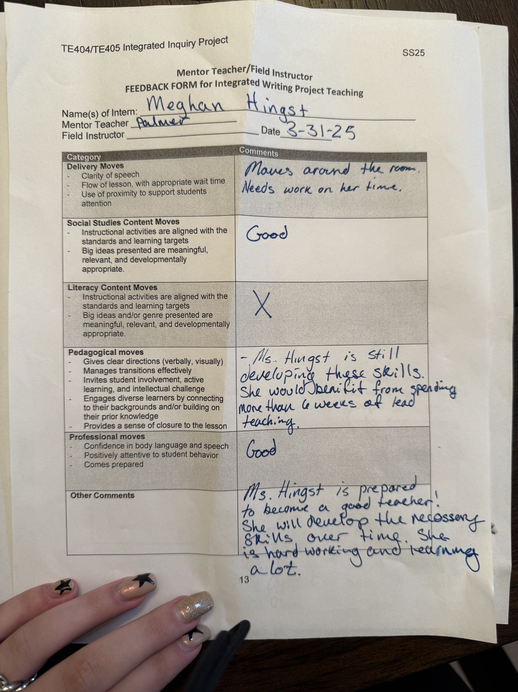

(This is the Social Studies teacher, Mr. Palmer)

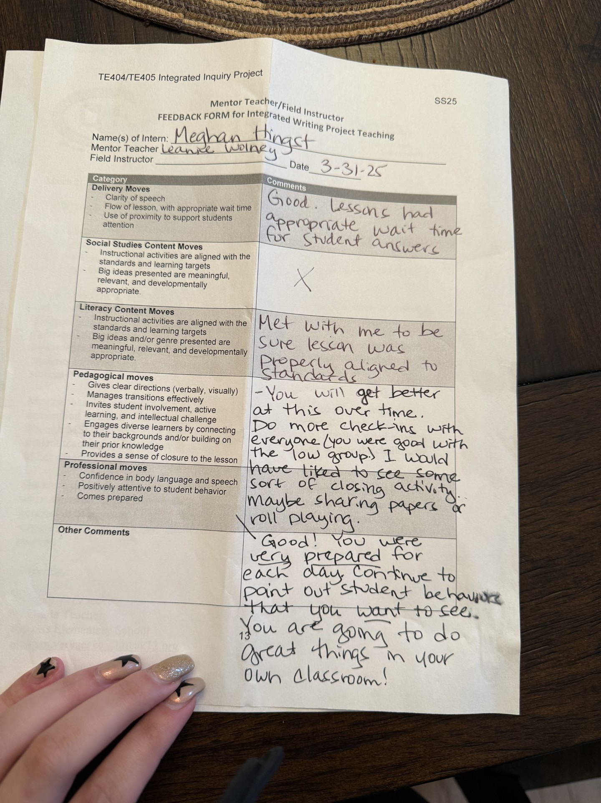

(This is the ELA teacher, Ms. Wolney)

**Student Work & Reflection on Student Learning**

For the literacy target goals, students were able to grasp the concepts of persuasive arguments. I was unable to get physical copies of student work due to needing to hand back their work, but I wrote down direct quotes from three students to include in this reflection. Student A has diagnosed ADHD, and I worked with him in a small group to complete his graphic organizer. In order to meet his individual needs, I supplied him with sentence stems. He was assigned the role of a loyalist for the persuasive essay. His given sentence stems were, “As a loyalist, I think we should stay with King George because ____. My first reason is ______. Next, I think _____. Finally, I think _______.” He filled in the sentence with the following: “As a loyalist, I think we should stay with King George because he kept us safe in the colonies. My first reason is because he gave us all the food and drinks we needed to live. Next, I think he protected us from the other country’s armies. Finally, I think he gave us fair taxes.” The student also added one supporting detail for each claim.

Student B was able to meet the literacy goals by using a translational tool. This student’s first language is Spanish, and he is fluent in it with little proficiency in English. I gave him the options of writing in Spanish or English, and he used a combination of speech-to-text and online translation resources to successfully complete the unit. I also gave him the same sentence stems as Student A.

Student C was able to meet the literacy goals by working with me in a small group. This student is a learning center student and needs small group instruction to complete assignments. I modified this assignment for the student by asking for three paragraphs instead of five to meet their needs. The student still showed that they met the learning goals even with a shortened assignment.

Student A met the social studies goals by completing his daily “anger chart” from the point of view of a colonist. The visual aid of anger helped the student make the connection between the curriculum and text-to-self learning. With this aid, he was able to form a deeper-level understanding of the reasons for separation from Great Britain while staying on task with the class. Student B met the social studies goals by having each writing prompt given to him in Spanish so he was able to successfully complete daily assignments. Student C was able to meet the social studies goals by working in a small group with myself and his learning center teachers with modifications. This student was given shortened writing prompts and was able to use visual drawings to aid his explanations each day.

Some students had longer responses than others each day due to their varying abilities, but overall it was evident that the learning goals were achieved. We used a variety of assignments such as anger meters where we rated our feelings as if we were colonists, drawings, posters, oral presentations, discussions, table charts, and daily journal writing.

**Reflection on the Unit and Refining**

The first change I would make to this unit would be the modes in which students could respond. I would make this change because I have learned that many of my students are proficient in typing and can use aids (spell check) to complete their assignments. I did not implement this change because I wanted my students to strengthen their motor skills as well as practice their handwriting, but I think it would have made each day more productive for them. The second change I made was implementing more visual aids. I have learned that my students have days where they respond better to the material when hearing it from someone else. Because of this, I supplemented my teaching with a variety of videos and clips pertaining to the topic of that day. I found that this change was a good idea because they seemed to grasp the information better when having it delivered to them in a multitude of formats. The third change I made was supplementing more outside resources than I originally planned. I ended up finding a “break-up” letter activity written from the colonists’ point of view to King George III. It contained slang and modern-day analogies that my students could relate to, and it made the content much more engaging for them. I think this was a good change to make because it made the students excited to learn about American history and the content was delivered in a way that was interesting to their age and social levels.

The students’ work told me that I had a strength in storytelling. My mentor for social studies always delivers his lessons in a storytelling format, and the students’ attention is held longer when we deliver lessons this way. I also found it interesting for myself how I was able to relate issues of the past to modern-day activities and issues that my students have experienced and could relate to. On the other hand, I learned that students do not respond as well to lecture. There were moments early in the unit where I would do most of the talking and students would lose interest and get off task easier than when I had student-based discussions. This led me to realize that students learn better and have more engagement when they are the ones leading the discussion and coming up with new ideas.

By implementing exit tickets each day with journal prompts, I was able to assess where students landed with the content each day. If more students were struggling on a certain concept, I would know to spend an extra day or two on that topic rather than jumping into the next lesson. This allowed me to better meet my students where they were at and ensure that understanding was happening before moving on.

Based on my students’ work, I believe the next writing sequence would cover narrative styles of writing. I chose this because I could sense students’ need to be creative during this process and I think they would benefit from a unit that integrates both social studies concepts and narrative writing styles. I want to remember to take more physical evidence of student work for their portfolios so that I may see their growth, their guardians can see it, and that the students can see their growth in their writing and understanding. This would have been beneficial during conferences as well. When teaching writing, I want to remember to give students as many opportunities to see model writing as I can. I learned that the more students have to base their work on, the better the result will be. I want to remember that writing can be integrated into any subject, but especially social studies because I feel like it is not often where we see writing being added into the social studies curriculum. It was rewarding to see students’ make connections across the content areas and be able to continue this skill today.